Writing Linear Equations
y = mx + b

Write the slope-intercept form of the equation of each line given the graph:

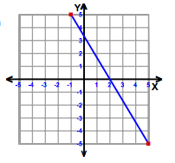
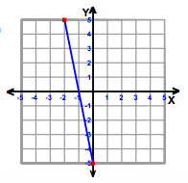

Find the slope and y-intercept from each table, and then write an equation:

m = ______________

b = ______________

equation:

___________________
_{X} | _{Y}
₄ | ₁₉
₆ | ₂₇
₈ | ₃₅
₁₀ | ₄₃
m = _________________

b = _________________

equation:

______________________
_{X} | _{Y}
₁ | ₋₂
₂ | ₁
₃ | ₄
₄ | ₇

m = _________________

b = _________________

equation:

______________________

_{X} | ₂ | ₄ | ₆ | ₈ | ₁₀
_{Y} | ₋₁ | ₀ | ₁ | ₂ | ₃

Coordinate point: (-7,5) , slope = - 2 | _{(-4,-4) , m = -1}
_{y-intercept = - 2 , slope = 4} | _{m = -5 , b = 7}
Write an equation of the line in slope-intercept form using the given information:

