PreAP Homework Wednesday 11/1/17

Read and solve each problem. Show your work for credit!

Find the unit rate for each of the graphs and include the description (ex: 2 mi/h).

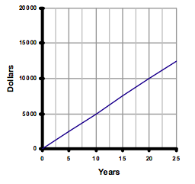
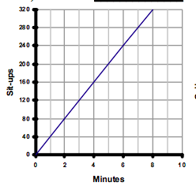
- 2.

Unit Rate = ____________________________ Unit Rate = __________________________

Find the rate of change (slope) from each table. Explain what the rate of change means in each problem situation (ex: 2 miles per hour). Also give the y-intercept (work backwards once you find a pattern).
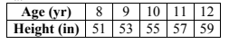
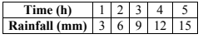
- 4.

Rate of Change = _______________________ Rate of Change = _____________________

y-intercept = ___________________________ y-intercept = ________________________

- Which line is steeper: a line with a rise of 13 and a run of 7 or roof with a rise of 8 and a run of 4? Explain your reasoning in complete sentences.

PreAP Homework Wednesday 11/31

Read and solve each problem. Show your work for credit.
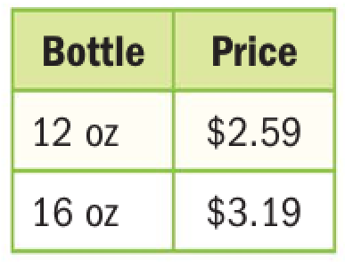
- Which bottle of shampoo shown at the right costs less per ounce? Explain.

_____________________________________________________________
_____________________________________________________________
_____________________________________________________________

- Damon created a table to represent how fast he can run. Complete the graph and determine whether the distance Damon runs is proportional to the number of seconds he runs. Explain.
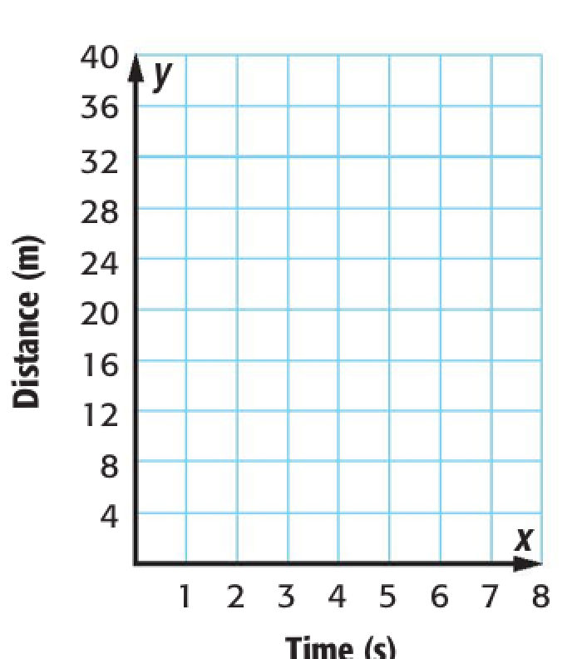
__________________________________________________
__________________________________________________
__________________________________________________

Time (s) | 1 | 2 | 3 | 4
Distance (m) | 8 | 16 | 24 | 32

- The table and graph show the amount of rainfall for 2 different days. Which day had a greater rate of change (greater rainfall per hour)? Give the slope and unit rate of each day and explain your answer.
______________________________________________________________________________



