Self-Test Questions: Tying up our UO

Referring to the 5 self-test questions on your unit organizer (UO) , answer the questions in the following spaces:

1. ___________________________________________________________
____________________________________________________________
____________________________________________________________
____________________________________________________________

2. ___________________________________________________________
____________________________________________________________
____________________________________________________________
____________________________________________________________

3. ___________________________________________________________
____________________________________________________________
____________________________________________________________
____________________________________________________________

4. ___________________________________________________________
____________________________________________________________
____________________________________________________________
____________________________________________________________

5. ___________________________________________________________
____________________________________________________________
____________________________________________________________
____________________________________________________________

Unit 3 CFA Review – OL

- Which table(s) of data illustrate(s) a constant rate of proportionality?

x | y
2 | 14
5 | 35
6 | 42
9 | 63
I.

x | y
1 | 44
2 | 47
3 | 48
4 | 50
II.

x | y
1 | 11
2 | 13
3 | 15
4 | 17
III.

A. I and II
B. II and III
C. I only
D. III only

- Mrs. Xander wrote the following sequence on the board:

Term | Number
6 | 16
7 | 18
8 | 20
9 | 22
10 | 24
n

Which of the following expressions could be used to determine the next number in this sequence?
A. 2n + 4
B. 2n – 4
C. n + 4
D. n – 4

- So far, this month Raul calculated that he will earn $30 in commission for his $200 in product sells. If Raul would like for his commission to be $132, how much more does he need in sales?

F. $680
G. $102
H. $880
J. $588

- Which graph displays the relationship between centimeters and millimeters?

Centimeters | Millimeters
1 | 10
2 | 20
3 | 30
4 | 40
5 | 50
N

F.
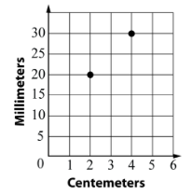
G.
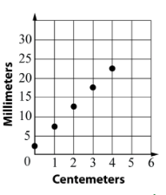
H.
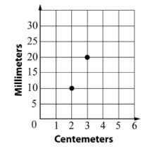
J.
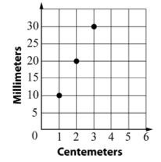

- The cost of Bill’s gym membership was $35.90 per month but increased by 8% per month. What is the new cost of his gym membership?

A. $38.77
B. $33.90
C. $33.03
D. $32.87

- Allison can cut 4 snowflakes in 10 minutes. If she cuts for 55 minutes, how many snowflakes can Allison cut?

F. 2.5 snowflakes
G. 137.5 snowflakes
H. 22 snowflakes
J. 23 snowflakes

- Trevor bought four bunches of grapes for $9. If Trevor plans on spending $18 on grapes the next time he goes to the grocery store, which proportion can be used to solve for x, the number of grape bunches he can buy?

A. $\frac{9}{18}= \frac{x}{4}$

B. $\frac{4}{9}= \frac{x}{18}$

C. $\frac{4}{9}= \frac{18}{x}$
D. $\frac{18}{9}= \frac{4}{x}$

- Kathy was pricing uniforms for a dance the holiday dance recital. The clothing store sold 3 different types of uniforms.

Style  1 | Style  2 | Style  3
6 outfits  $54.00 | 9 outfits  $75.00 | 17 outfits  $119

Which statement about the unit costs of the different styles is true?

F. Style 1 has a lower unit cost than Style 2
G. Style 3 has the lowest unit cost
H. Style 3 has a higher unit cost than Style 1
J. Not Here

- The table below shows Steven’s budget last month.

Expense | Amount
Food | $350
Cell Phone | $110
Rent | $770
Student Loans | $465
Credit Cards | $220

About what percent of Steven’s monthly budget was spent on credit cards?

A. 12%
B. 11%
C. 18.3%
D. 1.3%

- For breakfast every morning, Kendall likes to make a protein shake before she goes to work. Generally, she makes each shake with 2 tablespoons of protein powder to every 8 ounces of water. Today she wants to prepare extra shakes for later on in the day and uses 48 ounces of water. Which proportion could Kendall use to find p, the amount of protein needed for the larger amount in water?

F. $\frac{2}{8}= \frac{p}{64}$

G. $\frac{2}{8}= \frac{64}{p}$

H. $\frac{8}{64}= \frac{p}{2}$

J. $\frac{64}{8}= \frac{2}{p}$

